 Activity: BLAST
Basic Local Alignment Search Tool (BLAST)
BLAST refers to a suite of local alignment tools hosted by NCBI that find regions of similarity between sequences. Through BLAST, you can align unknown “query” sequences against a selected database of known sequences (referred to as “subject” sequences) and assess the statistical significance of alignments or matches. BLAST can also be used to annotate genome coding regions and to find sequences similar to your query when trying to assess how detected microbes fit within the known diversity (e.g., phylogenetic analysis).
See CZ ID’s A Guide to BLAST for details.

Part I: mNGS BLAST Exercise

Task: Identify three unknown sequences by running BLAST against the nucleotide database (NT). Fill out the table below using the provided query sequences and following the BLAST instructions.
Find query sequences here:
Appendix: PartI_ BLAST_QuerySequences

Unknown Sequence ID | Organism | Notes
Query_1
Query_2
Query_3

Instructor Sheet

Part II: Genome Annotation BLAST Exercise
Task: Your team recently sequenced a virus from a cruise ship outbreak of gastrointestinal illness. Answer the following questions about the identified virus using the provided sequence and following instructions for annotating genomes using NCBI ORF Finder and BLAST.
Find query sequence here:
Appendix: PartII_ BLAST_GenomeQuerySequences

What was the viral species sequenced from the outbreak? (Hint: use the same strategy used in Part I)
How many non-overlapping open reading frames (ORFs) > 600 nt does the genome sequence have? (See NCBI ORF Finder instructions)

Do these ORFs seem complete? (Hint: use BLAST function found in the ORF Finder Results page to figure out the size of known protein sequences)

Your team is interested in learning more about the viral group represented by the sequenced virus. Try the NCBI Virus database to answer these questions:
- Which geographic region has the most sequences?

- Have related viruses been identified in non-human animals? If so, can you list five species?

- Can you think of another question?

Instructions for Running BLAST:
- Navigate to NCBI’s BLAST online tool found here and select the Nucleotide BLAST option.
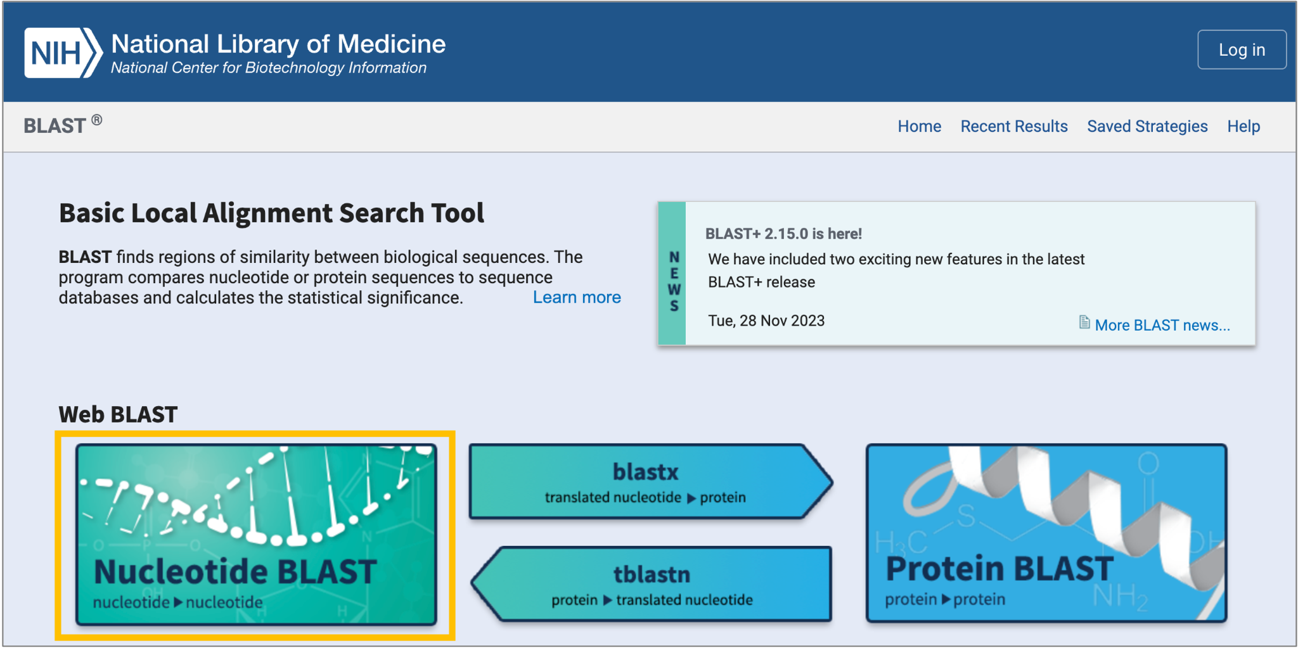
- Copy the query sequences (make sure to retain the FASTA format) and paste in the box with the header "Enter accession number(s), gi(s), or FASTA sequence(s)".
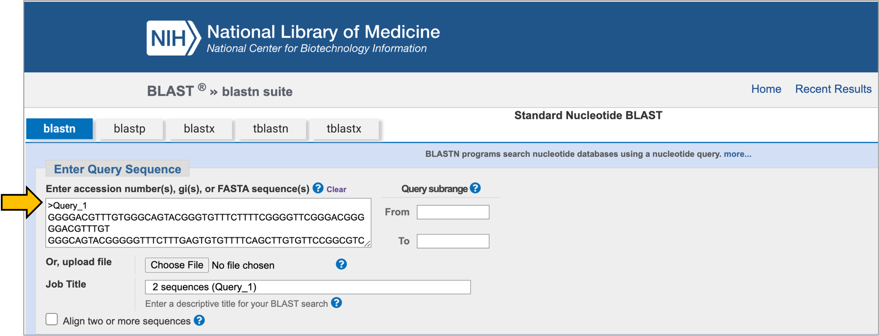
- Scroll down and click the BLAST button on the bottom, left of the window. You will have to wait a few moments for the web server to run BLAST on your query sequences.
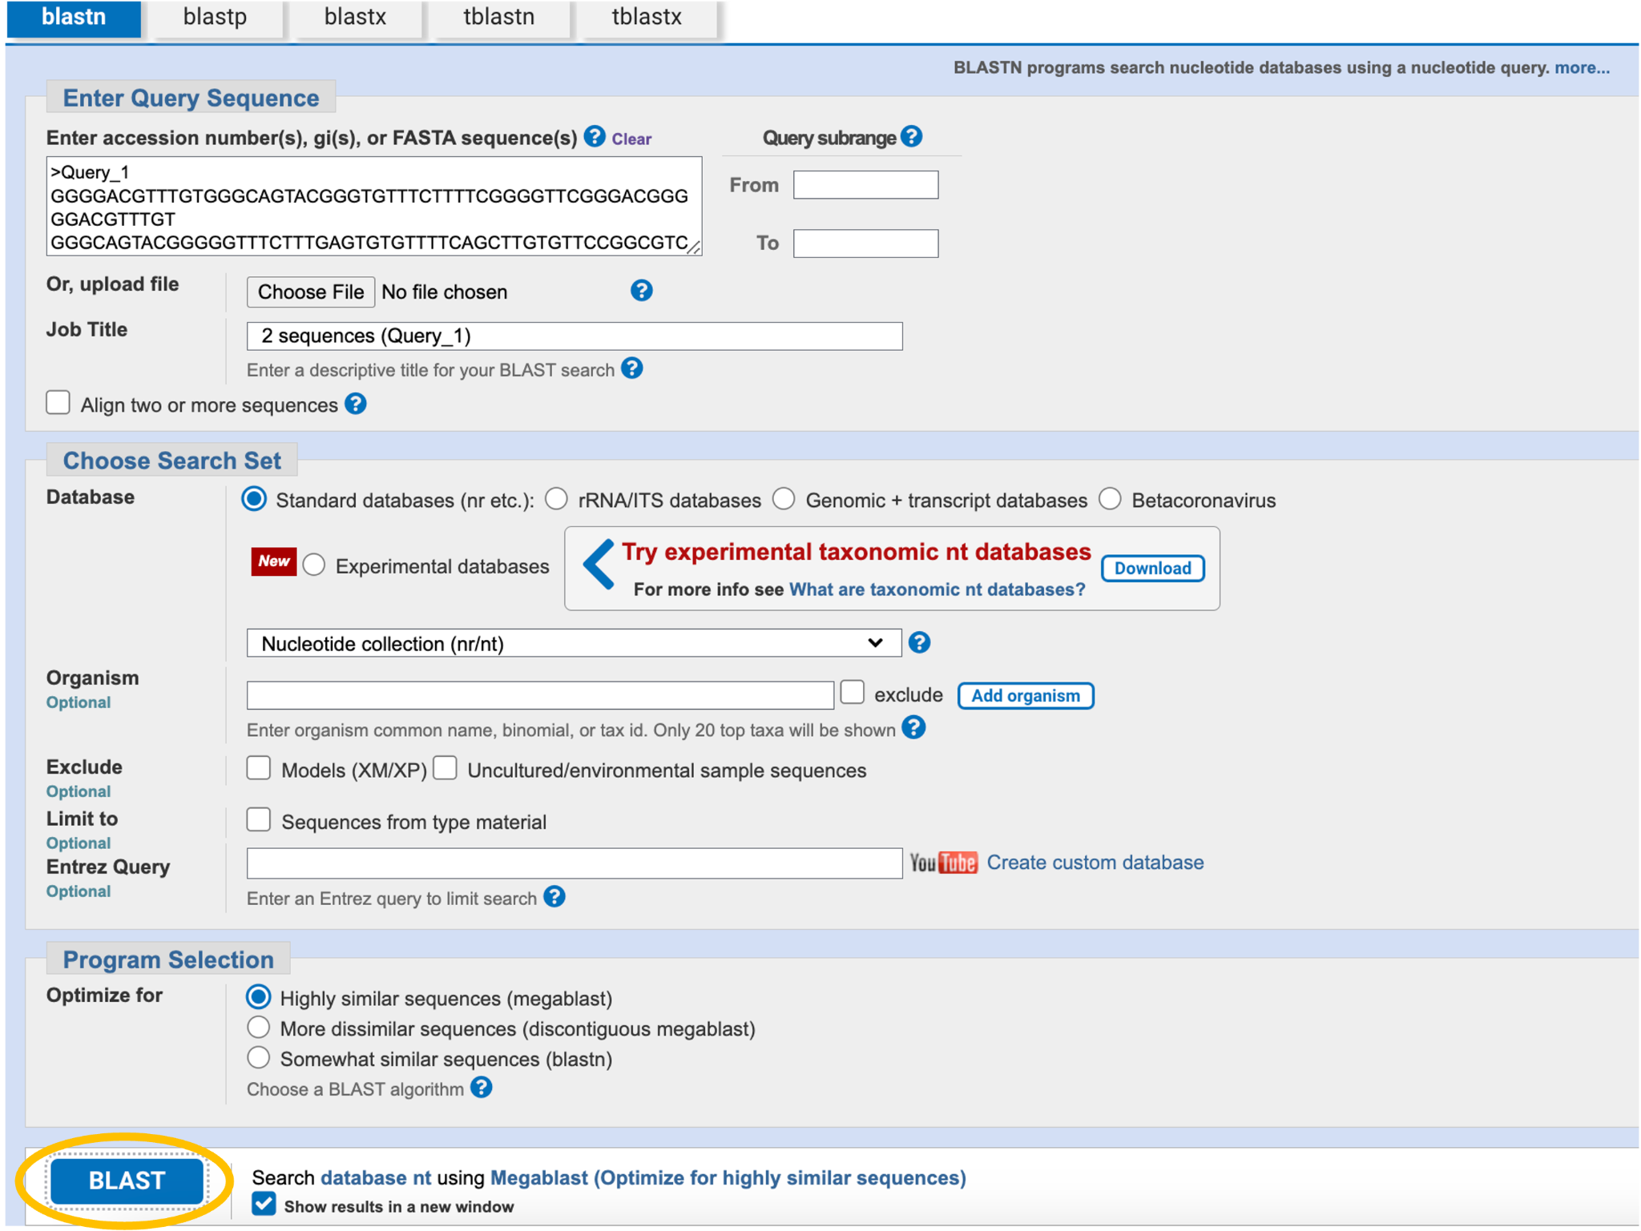
- Explore results once the BLAST Results page appears.

BLAST Results
The results page includes a search summary and tabs to explore results using a description table, graphic summary, and/or alignments that can help determine the quality or accuracy of a given match. The results are displayed for one query sequence at a time. You can view the results for a different query sequence by selecting it from the Query dropdown menu.
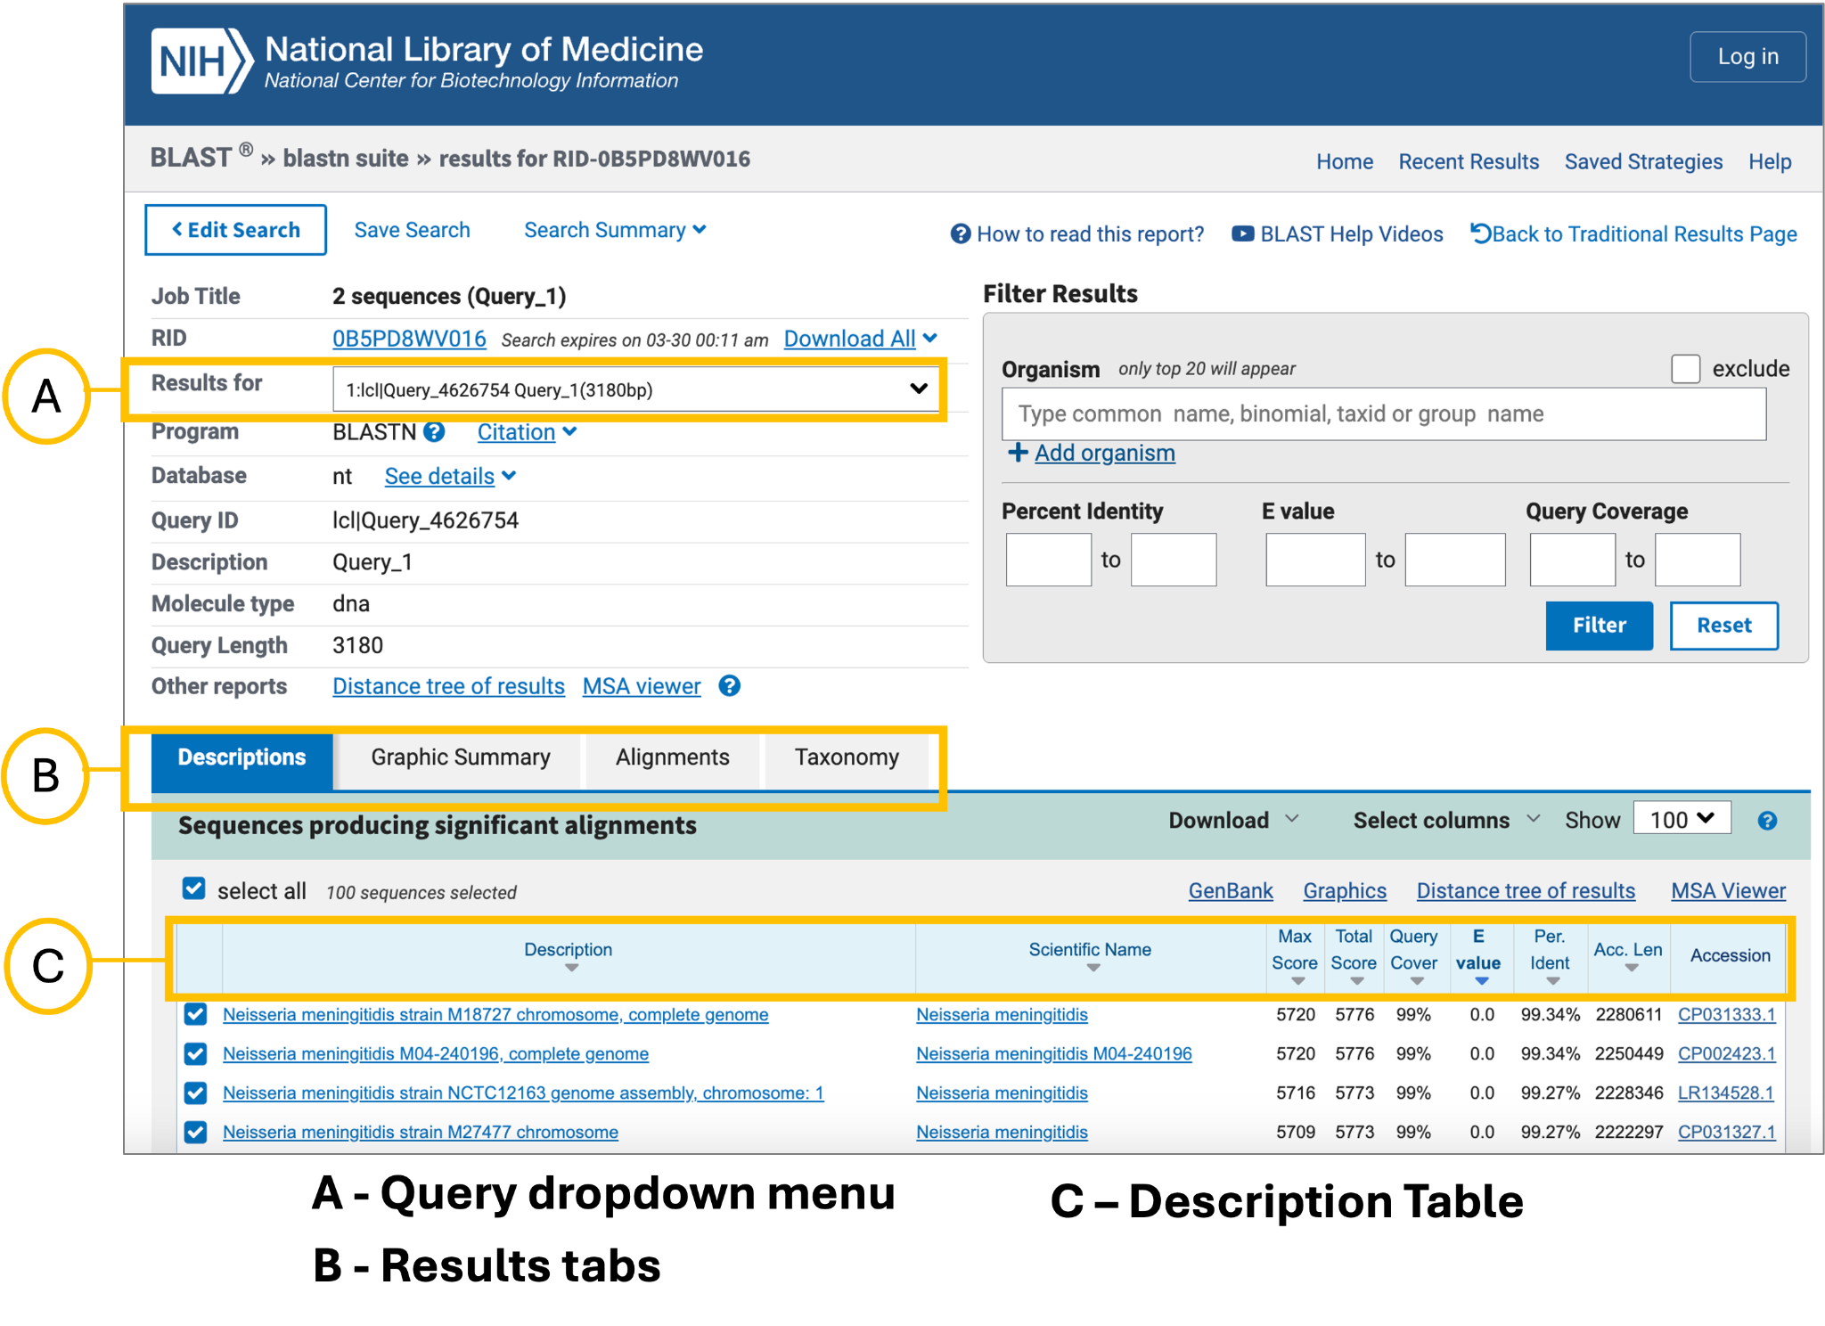
Click here for a CZ ID’s detailed description of BLAST result tabs.
By default, the results page will display the Descriptions tab which includes a table listing all the sequences sharing similarity with the query and metrics to evaluate the matches. The table includes the following information:
- Description: Species name of the organism represented by the subject sequence (match in the database).
- Scientific Name: Scientific name of the organism represented by the subject sequence (match in the database). Clicking on the species name link will take you to the alignment.
- Max Score: Highest bit score calculated from matches and mismatches found in local alignments. The higher the max score, the better the alignment.
- Total Score: Sum of alignment scores for all of the sequence segments or local alignments. The higher the score, the better the alignment. When max and total scores are the same, there is one global alignment between the query and its match in the database. This means that the sequences can be aligned without long insertions or deletions.
- Query Cover: Percent of the query sequence length that is included in alignments against the subject sequence.
- E value: Indicates the number of hits or alignments that are expected to be seen by random chance with the same score or better. The lower the E-value, the more significant the alignment (the closer to 0, the better). E-value is the default metric used to sort the Descriptions table and normally gives the same sorting order as Max Score.
- Per. Ident: Percent of nucleotides or amino acids that are identical between the aligned query and the subject sequence. A query sequence can share low percent identity with a sequence and still be a significant match. It is essential to take the E-value into account and look for similarity between conserved regions (this will be more evident at the amino acid level)
- Accession: Unique accession ID assigned to the reference sequence in the NCBI database.

Identify the top scoring organism(s) for the first query sequence. Then, navigate to the results for the next query sequence using the Query dropdown menu.
Interpretation Note:
- It is possible that a single sequence will map to multiple organisms. If there’s not a single species resulting in clear top alignment metrics, you can’t make a species call.
Explore the BLAST results for each sequence. Write down the name of the organism identified by BLAST. If the metrics do not support a specific species, write "unassigned".

NCBI ORF Finder
The NCBI Open Reading Frame (ORF) Finder searches for ORFs in sequences. An ORF is a stretch of DNA between start and stop codons. We identify ORFs to predict genes (or coding sequences) that are translated into protein. Based on known genomes, we can use ORF information to evaluate if we have the expected complete coding sequence of a given genome. Open reading frames shorter than expected, due to early stop codons, may point to sequencing errors.
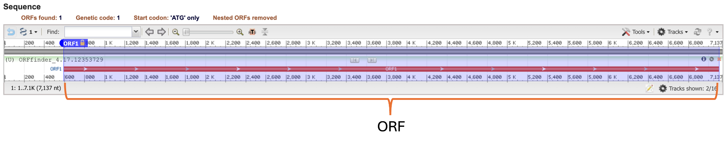
Open reading frames detected in a Rhinovirus A genome sequence using NCBI ORF Finder. Rhinovirus genomes are known to encode a single polyprotein.
Instructions
To detect ORFs in the sequenced genome:
- Navigate to NCBI ORF Finder
- Paste the sequence in the provided box.
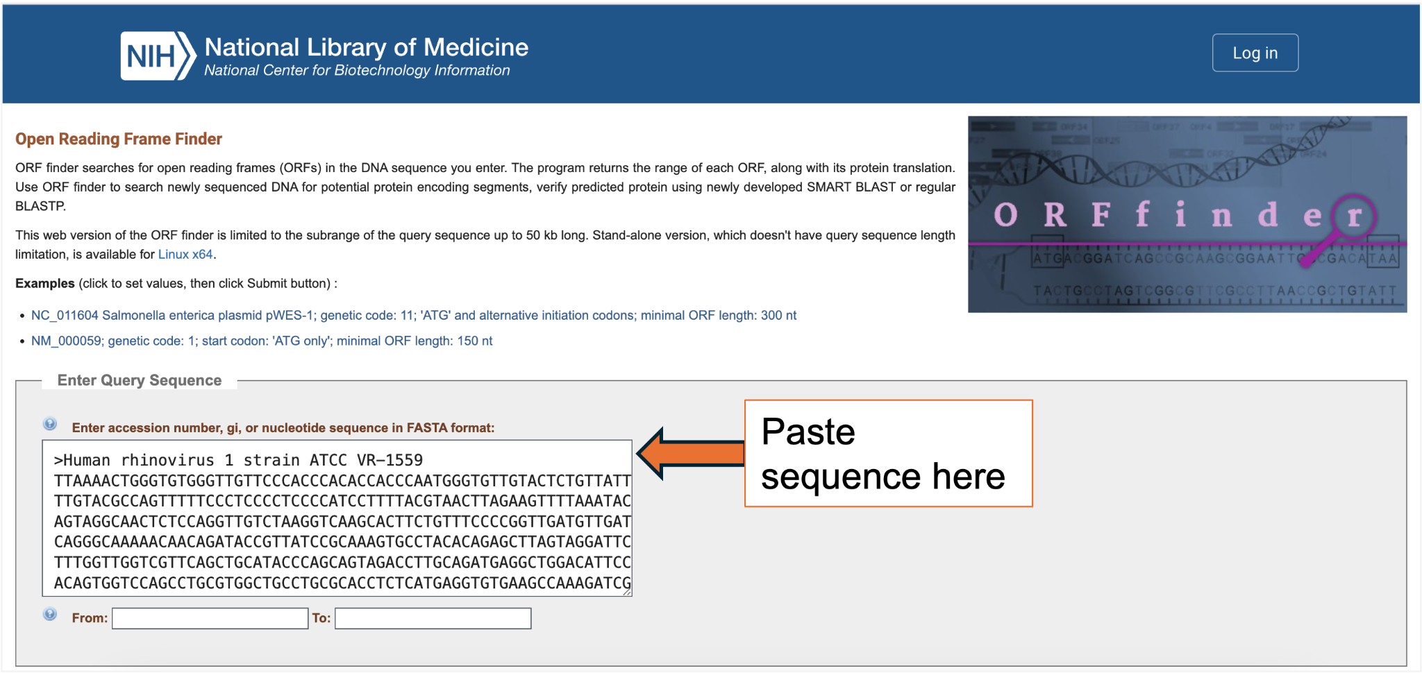
- Scroll down and and adjust the search parameters to focus on major non-overlapping ORFs (> 600 nt).
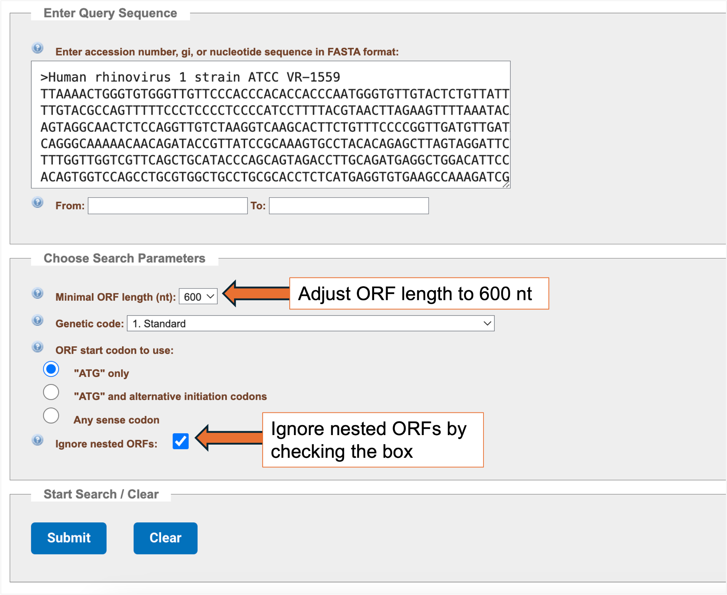
- Click the “Submit” button to start the search.

ORF Finder Results
The results page includes a schematic of identified ORFs, ORF sequence information, and buttons to BLAST predicted protein sequences.
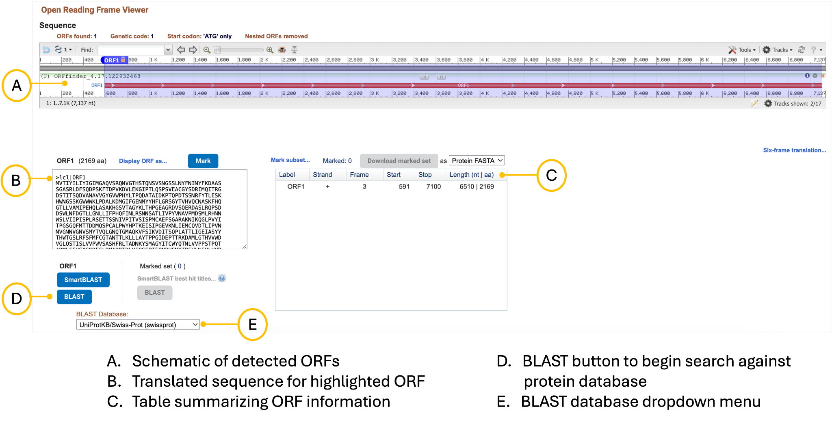
You can search protein sequence databases to find more information about detected ORFs. For the purposes of this exercise, change the BLAST Database to “Reference proteins (refseq_proteins)”. When you click the BLAST button, you will be directed to the BLASTp webpage given that you are now searching translated sequences against the protein database. Click the BLAST button to begin the search.
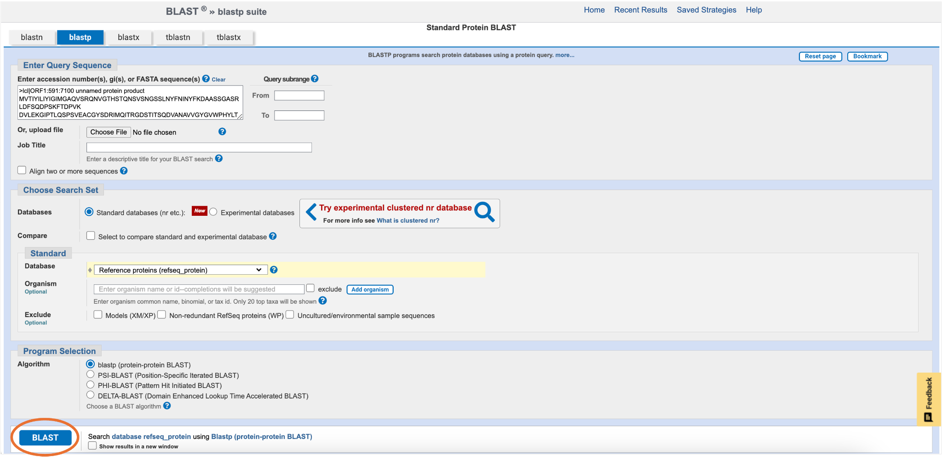
Look at the Description and Alignment tabs of the BLAST results page to see how well the predicted ORF aligns with known protein sequences.
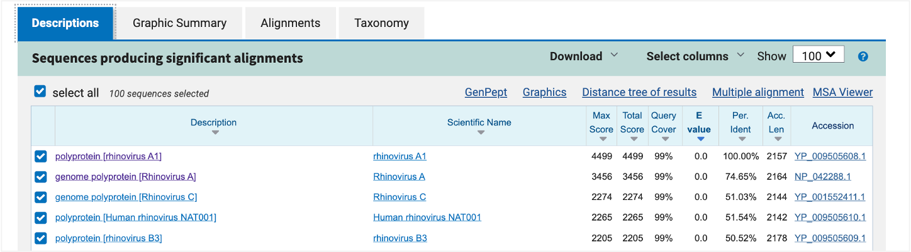

NCBI Virus
NCBI Virus is a database for the retrieval, display, and analysis of a curated collection of virus sequences and large sequence datasets. Notably, the database contains standardized metadata so users can easily find sequences of interest.
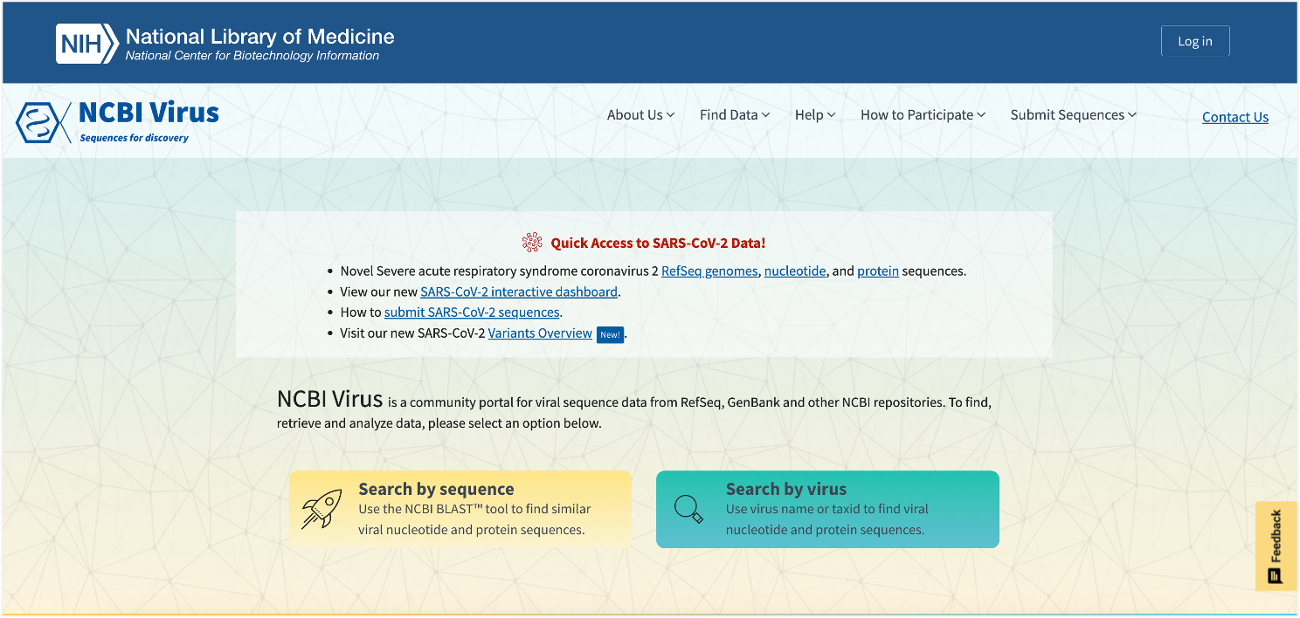
NCBI virus home page

In NCBI Virus you can:
- Find sequences similar to your query by running BLAST against the curated database
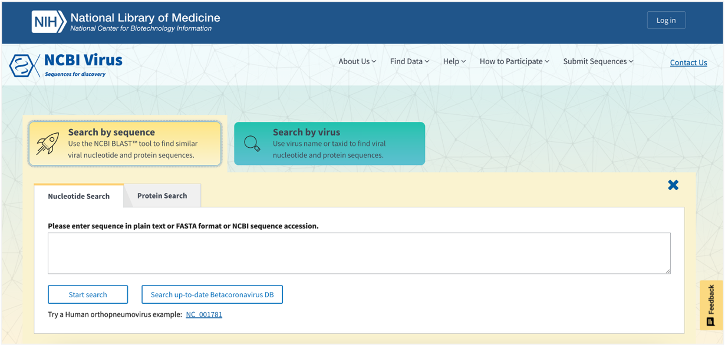
To find similar sequences to your query, paste the query in the provided box and click “Start search”.
- Search for viral species or groups of interest using virus name or taxID
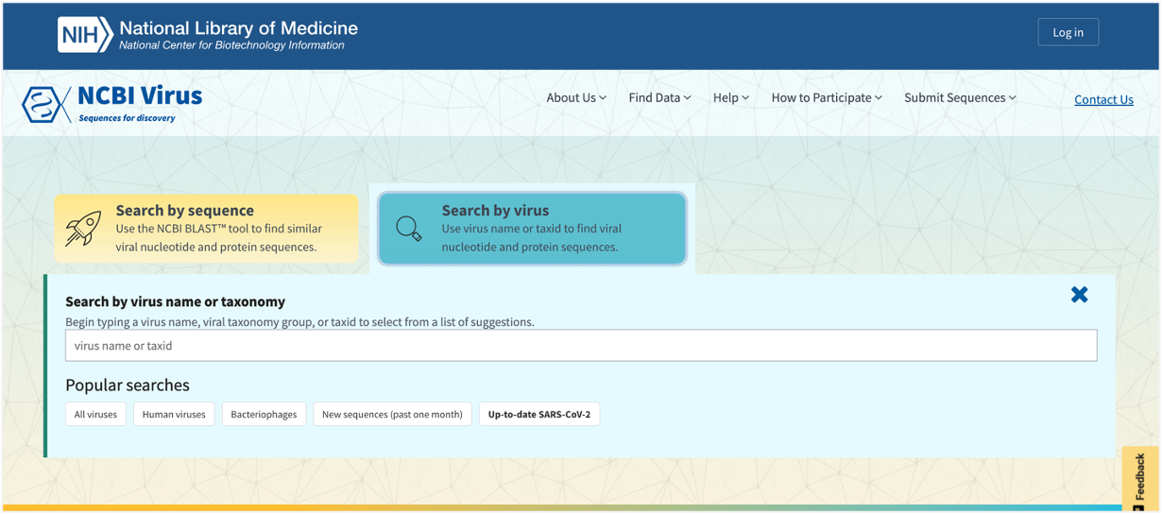
Type the virus name or taxID for the group of interest in the provided box.

- Refine results by filtering based on metadata of interest.
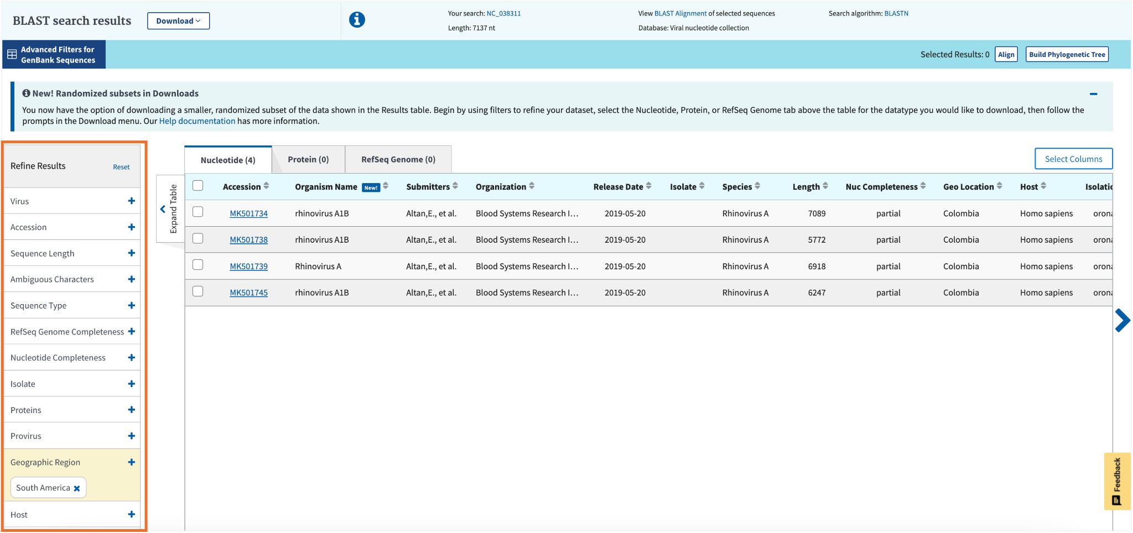
Use the filter menu on the left hand side of the Search Results page to refine results. (e.g., how many Rhinovirus A genomes from South America are available?)

APPENDIX

PartI_ BLAST_QuerySequences
>Query_1
ATTTCCTTTTATGTTTTGGGTTTATCGAGTTTTTAGTGTTAGTAAATGAGTGTTTGTGTA
TTTGTTAAGTGTTGTGATGAAGTTTCCAGTATTATTTTTTTGTTTTTTGTATGAAGTGGA
AGATCTAGAAATTGTTTACATTGATTGTTTTTTTACTATTTTTTGTTGTTGCTTTTTAGT
ATGATTTTTTAGATTTAGTTGGGAGTATATTTGATGCCACATATCATTAACTTCTGTAGC
TACTTTAGTTGTGGCATGTTTTTGTAGTAATATTGAAGTGTGCTTTTTTATATATTGATA
TTATTTTGTTTGATCTAGTTTTAGTATAGTTTATTTTGCATTAGTGTCTAGTATAGGGGA
TTTAAAGGGTTATTTTTTTTGAGTTTTTTGTTTTTTGTTATTGGTTACACCTGTATCTTT
TCCTTTATTTTATAAGTTAAGTGTTAGTATTGGTATTTTATACTCGTCTATTTACTTGTT
GTTAGTATGAAGAATGTATAGATTTTCTGAACAACTCTTTTTGTATAAGTTAGCTAGGGA
ATATTTTTATGTTAACGTTTTTAAAAATTGGGTGTAAAATTGGTAGAGTTGAGTTTTGTG
TGATGTAGTTTATTGAAAATACTTGTTTTACACACAAGTGAACTCTTGTTGGGAGCTTTA
CTATTTTGTTTTATAAACGAAATAGTTTAATTGAAAAATATTGGGTTTGCATCTCAAAGA
TGGATATATGTTCTTTTGTTAATTAAATGTGGTTTTAGTTTAATGAAAATAGTGATTTGT
CTAGTCATAGATAGTAGTTTAATAACTAGGCCACTTAGTAGTTTAGTTAAAATGATTATT
TTTGGGTTTATTAGTGGTTTTATGGGTTTGTTAATTTGTTTATTAATTATAGCTTTTTTT
ATATTAGGGGAACGTAAGATTTTGGGTTATTCTCAATTTCGTAAGGGTCCTAATAAGGTT
GGTATTGTAGGATTGTTACAAAGGTTTTCTGATTTATTAAAGTTGATAATTAAGTTTAAG
AATTGTGGATTTCAGAGTCGTAGTTGAGTTGGTTTGTTTGGGGTTATGTTGTTGGT

>Query_2
TCTGGTCGCAAGCGCTTCCCTTTCAACAATTTCACGTGCTTTTTAACTCTCTTTTCAAAG
TGCTTTTCATCTTTCGATCACTCTACTTGTGCGCTATCGGTCTCCGGCCAGTATTTAGCT
TTAGATGAAATTTACCACCCATTTAGAGCTGCATTCCCAAACAACTCGACTCGTCGAAGG
AGCTTCACACGGGCGCGGACACCCCATCCCAGACGGGATTCTCACCCTCTCTGACGGCCC
GTTCCAGGGCACTTAGACGGGGGCCGCACCCAAAGCATCCTCTGCAAATTACAATGCGGA
CCCCGAAGGAGCCAGCTTTCAAATTTGAGCTCTTGCCGCTTCACTCGCCGTTACTGAGGC
AATCCCGGTTGGTTTCTTTTCCTCCGCTTATTGATATGCTTAAGTTCAGCGGGTATCCC

>Query_3
CTCACAGCAAAGAAAAACTTTTTAAACCTTTATTAAAGCAAGTGCGAGTAATTACGCGCA
ATCCATTGATCAGAAGGAACTTCATACACTGGCGTGTTTGGGTCTTGTAAGCTATTAGCA
AGAGTAAATGGCATACGCCCGGAATCTGTTGTGGGAAATGGAGCAGGTTTCTCGGGGTTA
TGACGGCGAGATCGCTTGCGGCGCTTAACTAGAAACTGCATGCTATAGTGCAAGTGAAAA
ATGGCATACTGGTTTAAATTAGATTGGGGAACTGTGTGGGCTCCCGGACTGGGAGGTCCG
GGCTGTGATCTAAGTTTAACAAATATCATCGGTGGCGGAGTCATAACTCCCCAACCACCT
AAAAGAGGATACTGAGCAAAAAAATGGCATTCTGTATTAGGAATTTTAGTCCATATTTGA
CAATCATATGATAAAGGATTTGGGTTCCAAACAGCACCAGGAAACAAGGGAAACACAGGT
TCTTGATACAATTTTGGGCTGTACACTGTATCAGTACCACCAGATGTCACTCTAGTATGT
CCAGGAACAAAGAATGTATGGCCCACATGTGGAGCAGCCAAGTCACCATCTATCTGAACA
ACTCTAGATGGATTACTAACTCTGCCATCACGGTCCTCTTCATGCTTATCGTAAGATTCT
TCATGTTTTCTTCTAGTGTATGCAACCCCTCCCAAATAATTATGTACAGAATAATCAGTT
TTGTTTGCTAACCATTCTTCTGTGCGAACAGACCATGGCTGATGAACTAATGGAGCTACA
CTGTATCTATCACTTGTAGCAGGATTTCCAATAGCAACAGGATCCCTAAAAGTTGTGTTT
CTAATTTGTGTGTCTGTTGGCATCATGAGAGCTGGTCCTGGAACATAATTCAGTGGAAGC
CTGCCAACATCCATGCCTTCAGGACGTTTCCAAATGGCAGTGCCATCACTGTCAACACCT
GTCATAATAGCTAATCTGCTGGAAGGAATTGGATTATGTCTTGCATACAAAGTTTGGTTT
GGAGTTGATAGCTTTCTCCAAGGTAGATCATCTGGAAATTCATAATGATGAGACCAGTGA
TCTCCTGTTCCTAAACACTCTGCATCATGGTGTTCTAGAAAAAATAGTTCTGTTTTATGA
TCACTGATGGCCACAATGCTGTTCTGTTGATCAATTTCTCTACCTCTTGTAATGTATCCA
TACTGAGGCAACACATAATTTTCCCCTGGTAAATGACCTGGTAAAGTATCTTGATTATGA
CCCAATACATATGGATAGTCATAGCTATCATCAGCAAATACAGTTATGCCACCACTCGCA
GAATCAGAGACAGTGGTGCCTGTCTGATTAGTTGCAACATCCTTGATTACAATAGCAGAG
ATTGCAATAGTTAGGCTTTTAGGCTTGATTTCATCATATTCATCTAGTAATTGTTGAAAA
TCTCTGGGAGTAAAATGAGCTGATAAAGCATTAACATCAATGTAAGAATAAGGGGTTTTC
ATTCCCATTACAGGCTGCGAAGAATCTACATGACTACCTTGCTTATACACAGGCACATAA
CCTCCTCTATCAGCTAACATAGAAGTTCTAGTATGAGAAGTAATAACTACAGAATCAGAG
AAACTAGTCCCACCTATCCACTGAGCTTTAACTTTAACTCCACCTCCTCCTCCAGCTGGT
TCCACGGACATTGTATTGGTATCAGACTGCACAGGCAAGGTTGGTTCAGACTCCTCAGGG
GTACCAATCCGCGCCTTCTTGGCTGAGGGCTCTCCTGCGGAATAAGCCGGTTGTTGGTCC
GAAGAAGGAGGAGCGGGCGGTAGGACCTGAGAAAGTTGAACATCAGCAATATCACCAACA
GTTTCCTTAGCCTGCCATAAACCTCTAATAGCATTGCCAACTACTACATCTGCCAAGTGA
GTAATGTCCCCCCGGCGCTCTTTTTCTTCTAACTCTTTGTTCATTAATCTGTCAGCGCCG
TGACCATGTAAATAAGGAATGTCCCCGTGCTCAATCATCTCTGCGTACCGTTCATCATGA
TGTTTTGCTGCCTCATCCACTGGTCCCTGAGGGGGACCACTATCCAGAGGATTACCAGGA
CCAACATAATTATACCCGGGGAGAGTAAGCCCGCCTCCGGCAGGCCGCTCAAAGTCTGGT
TCAACAAGGGAATCAGCTCCTTCATCGCGGCTGTCACTAACAAGGTTGACTCCGACATCT

PartII_ BLAST_GenomeQuerySequences
>Genome
GTGAATGATGATGGCGTCTAACGACGTCACCCCCTGTGGGAATGAAATTCCCAAGACTGAAATCAACAAC
CAGTCTTCCGGTCGCATAGACCGACAGGCTGAAACAAGAACTACCACCGGCACCCAAGATGGTGCCCCCC
CAGCGCCAGCTGGGGGCTTCTTCACCCGCCTCAAGGATCGGGTGAAGCAACCTAAGGCCCCCCCACCCCA
ACCCCCTGGCCATGAGACCCAGCGTCAGGAGGAACCGGTCGTCACTTACGAGGTGAGGACCGAGGCCGTC
CGGGGCGTCCCTGACGTCAAGGCGGCGGATTTGCCTCCAGGCTACGTGGTCCCCCCCCATCTGCCACCAA
TAAAACTGAGGGAGTCCCAAGATGCCCCAGAACCCCCGACGGGCGCCATCCTGGAGATGTGGGATGGCGC
GTACTATCATTACGGGGTTTATGTTGAGAAGGGGCTGGTGTTGGGCATACATAACCCTCCTGCTGCCCTC
TCAGAAGCAACGGTTGAGCTGATACCAATATCGCTCTTTTTCCGAGTGGTGCACGTTCCATCCAACCGCC
CGAGCATCCGCGCACTCAAGAGGTTGCAAGGGGAGAAGTACCCGTACAACGCACTCACCCACAACTGTTA
CACCTTTTGTTGTGAGTTGCTTGAGTTGGACGATGACTGGGAGGCGAGACGACTCGTTCAGCGGACGACC
GGGTTTTACGACCCCAATCAACGCTGGAACGATAAACCAGTGCCCTTGGTCGCGGACTCTCGCGTTGTAA
AAATCGCGGATGCCTTGCTCGCCGCACTGGCGGGCGTGGCGGCCCAACCAATTCGCGACATCGTGAACAA
ACTGAAGCCTCTCAATGTCCTTCACATCCTGTCATCTTGTGACTGGACCCTCTCTGGAGTTGTGGAGATG
GTCATCCTTCTGGCCGAACTCTTTGGCATATTCTGGACCCCCCCTGATGTCACCCCCTTGATAGTTTCGC
TTCTGGATGATTGGGAAATGCAGGGCCCGGAAGACCTCGCGGCAGAACTGGTCCCCATCGTCCTTGGTGG
GATTGGACTGGTGGTAGGTTTCACACAAGAGAAGGTCGGCCGTCTAGTGACCACCGCGGTCTCAACTCTC
AAGTCATGCAAGGACCTTGGGCTCTATGGGTTGGAGATCGTGAAGTTAATCGCCAAGTGGTTTTTCCCCC
GTAACACCCCAGGGGAGTCAGACCAGCTCCATAACATCGAGAATGCAGTGCTCGATCTAGAGGCCATAGA
AAGCAACAACTTGACATCGCTCTTGAAAGACAAGGCTCTGATGACAACTTTCATCCGCACCCTGGACGCA
GAGGAGGAGAAGGCCCGCAAGCTTTCATCAAAAGCAGCCTCACCCGATGTTGTCGGCTCAGTCAATGCCT
TGCTCTCCCGCATAGCAACCACCAGATCCCTGATCCACAAAGCTAAGGAGGAGCTGTCGACCCGGCCCAG
GCCGGTCGTCGTGATGGTATCCGGCCGCCCAGGCATTGGAAAGACCCATCTGGCTAGGACGTTAGCCCAG
AAGGTCGCCCCACAAATAGGCGGAGACCAGAGGGTTGGACTTGTCCCGCGCGAGGTGGACCATTGGGACG
CCTACCGTGGTGAGAACGTCGTCCTTTGGGATGATTATGGGATGGCCAACATAATAAAGGATGCCCTCAA
GCTGCAGGAGCTGGCAGATACGTGCCCTGTGACCCTGAATTGTGATCGAATTGAGAATAAGGGTAAAATG
TTTGATTCTGATGTCATAATAGTCACCACCAATGCCCCCAACCCAGCCCCCATGGACTATGTCAACATGG
AGGCAGTGTGTCGCCGCGTGGATTTCCTCATCTACGCCGACTCCCCGAGCGTTGAACAGGCTAAGCGCAA
TAATCCAGGGGACCCTAATGCCTGGAAGCCCCACTTTAAAGGGGACCACAGCCACCTCAATTTACAATTG
GCCCCCCAAGGTGGCTTTGACAAGAGTGGGAACACTCCCCACGGGAAAGGGCCGGTGCAAAAGATCTCGC
TGCCCAGCCTCATAGCGCGGGTTGCGGCGCTAGTGCATGAGAGGAGGGATGACTTCCAGTTGCAGGGGCC
CGTGAAGACTTATAACTTTGATTCCGGCCGCGTCTCAGCGTTCAGGCAGCTGGCCAAGGATAATGGTTAC
AGCTTGGTGGAGACCATGAAGGTAGGCTCGGCCCTCAAGGACGTCACAGATATGGAAGGGCTGATGCGTG
GGCTTCAGGGCGTTCGCGTCTCTCCCTGCCAGATTGTTTACCGCGGCACCACCTATTCCTTGCACTCTGG
TAGTGATGGGGTCAAGATCAAGCCTATCGTGAGCCAGAGGACACAAGCAGAGTCTGCGGTCCACACCGCC
GTTCTCCGCCTGAAGCGCGCGCGTGTGCGCTATTACATCAGGGCCCTACAGGATATTATTTCCACCCTCC
TCCAGATGGCTGGCTCAGCTTTTGTGATTAACAGAGTGCTGAAAAGAGTCGGAGAATCTCTCACATGGGT
CAAAGGGGAACGCTCACGGTCGCCCCCCCCAGTCAGGACACCCGACTGCAAATGGGTCATTGAACCTGAG
GACTTCGATGACGAGGGGAAGAAGGGCAAGAACAAGAAGGGCCGTGGGCGCAAACACACCGCGTTCTCCA
GCAAGGGGTTGTCAGATGAGGAGTACGACGAATATAAGAAGATTAGAGAAGAGCGAGGTGGGAAGTACTC
CATACAAGAATACCTTGAAGACCGCAACAGGTATGAAGAGGAAGTGACCCTAGCCCAGGCCAACGAAGAG
AATTTTACCGAAAATGACGCCGCCAAGATCAGGCAGAGAATTTTCCGGCCAACCCGCAGGCAGCGAAAGG
AAGAACAGAGAAACCTCGGCCTCGTGACTGGATCGGAAATCAGAAAGCGTAAGGCGGATGACTTCAAACC
ATCGGGAAAGCTCTGGGCGGATGACCAACGGGAGGTCGACTACGGGGAGAAGATCGATTTTGAGGCGCCA
CCTAGCATCTGGTCCCGTATTGTCCCTTTTGGCACGGGTTGGGGTTTCTGGGTATCACCCACACTCCTTA
TAACGGCCACCCACGTGGTCCCCAATTCCAAGGAGTTCTTTGGTGTGCCAGTGGAGCAGATTCACGTCCA
CCGCTCGGGCGAGTTCACGCGCATGAGGTTCTCGAAGCCAGTGCGCACTGACCTCTCTGGTATGGAACTG
GAGGAGGGAGCCCCTGAAGGCACCGTCTGCAGCGTCCTGGTCAAGCGCAACAGTGGGGAGATGCTGCCCC
TTGCCGTGAGAATGGGCTCCCACGCCACCATGAAAGTGCAGGGCAAGGTTATAGGCGGTCAATTGGGGAT
GCTGCTGACGGGGGCCAATGCTAAGAACATGGACCTGGGGACCACCCCCGGTGACTGTGGCTCCCCTTAT
ATCTATAAGAGGGGCAATGAGTATGTTGTCATCGGAGTCCACGCCGCGGCAGCCCGTGGAGGGAACACGG
TCATCGCTGCAGTCCAGTCTGGGGAAGGGGAGGCTACCCTGGAGGGGGCCAATGATAAGGGGACCTACTG
CGGTGCGCCCATCGTTGCTCCGGGCGGGGCCCCCCAATTAAGCACCAAGACCAAATTCTGGAGATCTTCC
ACGTGTGACCTACCTCCAGGAACATTTGAGCCCGCCTATCTGGGTGGTCGCGACCCCCGGGTGGAATCAG
GGCCAAGCCTCCAGCAGGTGTTGAGGGAACAGCTGAAACCCTTCACGGCCCCACGTGGCCGCCCCCCAAA
TCCATCCCTTCTCGAACAGGCGACAAAGACCATAGAGAATGTCCTCGACCAGACGTTGGACACGGTGAAG
GAGTGGACTTTCAACCAGGCGTGCGAGAGCCTTGACAAGACCACGTCGAGCGGCTGGCCTCACCACGTGC
AAAAGAACCAGCATTGGAACGGACAGCACTTTACCGGGCCGCTAGCAGACCAGGCCAGTAAGGCAAACCT
CATGTACGAGCAAGGAAAGAACATGCTCCCAGTCTACACCGCCGCACTAAAAGATGAGCTAGTCAAACCC
TCCAAGGTCTATGGGGAGCCCAAGAAAAAGAGGCTGTTATGGGGTGCCGACTTGGGCACCATGGTGAGGT
GTGCGCGCGCCTGGGGTGGCCTCCTCGATGAGTTGAAGGCAAACTGCGTCAACCTGCCAGTGCGCGTCGG
GATCAACATCAACGAGGATGGCCCGATCATCTTCGAGCGACACGCACGGTACAAACACCACATTGACGCG
GACTACAGTGCCTGGGATTCGACACAGCAACGTGTCGTGATGGAGGCCGCCCTGAAAATCATGAACAAGT
TCTCACCAAGACCGGACCTGGCCGCGGTTGTTGCCCAAGACCTCCTGGCTCCCAGCCAACTGGACGTCGG
TGATTTCGTCGTCCGAGTCAGCGAGGGTCTGCCATCTGGCGTCCCTTGCACCTCTCAACTTAATTCTATC
ATGCATTGGCTGCTGACCCTGGTGGCGCTTTCAGAAGCGACTGGATTGAACCCCGATGTTGTGCAGGCAA
ACTCGTGCTTCTCCTTCTACGGCGACGATGAGATAGTCTCGACCGACCTCGACGTCGATGTGGAGGTTTT
CACTCTGAAGCTGAAGGCCATGGGCCTGAGACCCACTCCGCCCGACAAAAGTGATGGCCCGCTAAGGGTT
CACACCAAGCTTGAGGGGCTGTCTTTCCTGCGCAGAACCATCCGTCGCGATCAGGCTGGCTTCTTTGGAG
CCCTCGATGCGGCTTCAATCGAGAGGCAACTCTACTGGACGCGTGGGCCAAACCACCAAGACCCCCAGGA
AACCATGGTCCCCCACAGTAATAGGTGCATCCAGTTGATGGAATTATTAGGTGAGGCTGCGCTCCACGGG
AAGAAATTCTACACCAAGATATCCCGCATGGTCATCCAGGAGGCTAGGGAGGGGGGCATGGATTTCTATG
TGCCGCGCTTTGAGCCCATGTTCCGGTGGATGCGCTTTTCTGACCTAGATAGTTGGGAGGGCGATCGCAA
TCTGGCTCCCGAATTTGTAAATGATGATGGCGTCGAGTGACGCCACTCCCCCTTCTGAAGGGGCCACCAA
TCTGGTTCCAGAGGTCAACACTCAGGTGGTCCCGTTAGAGCCCGTTGCGGGTGCAGCTGCCGCCGCACCT
TTTACGGGCCAAAACAACGTTATTGACCCCTGGATATTTCAAAATTTTGTGCAAGCTCCCCAGGGAGAGT
TCACCGTTTCCCCCCGCAATACCCCCGGTGAGATTCTCCTGAGAATACCATTAGGCCCCAATCTCAATCC
TTTTCTTGCACATTTGTCCCGCATGTATAATGCCTGGGTGGGTGGCATGGAGGCCGAGATGATATTGGCT
GGGAATGCGTTTACAGCTGGAAAACTCTTGATTGTGGCCCTCCCCCCTGGTTTTGAAGCGACCCAGTTGA
CCCCGGCCCAAGCCACGGCCTTCCCTCATGTCATCGCCGATGTTAGGACCCTTGAGCCCATTCCAATTCC
ATTGCCTGACATCAGAAATGTTCTGTTCCATTACAATGGTGATCCCACCCCAACCATACAGATTGTTGTC
ATGCTGTACACCCCACTCAGGACCAATGGCAACGGGGATGATGTGTTCACAGTGTCTGGCCGTCTGCTCA
CCCGCCCGGCACCGGATTTCTCCTTCTCCTTCCTGGTTCCACCCACGGTGGAGCAGAAAACCCGATCATT
CACCTTGCCCAACCTTGCGGTTTCAGATCTGTCCAATTCCAGATTTCCAGCCCCTGTAAATATTCTGAGG
GCCGATCCCAACACCACTCTGGCCCTCGATTATCAGAATGGGAGGTGCACGCTGGATGGCGCGCTCCAGG
GCACGACCCCCACCAACTCCAGTTTCCTGGGGTACCTAAGGGGCACTGTGGACCGGGTGAATTCCGATCA
GGTCCACGTCCACTTGAGGGAGCCCAACGGTGACCCCTTCCAACTCGGGCTTCCTGGCCCCCAGGGAGTT
CCAGACTACCGGGCCACCCTTGACATCTACGTGGACTGGGAGAACAAGAATCATGGCAATCCATGTGAGG
GCACCCTCAACACAGGCTCGCAGACTGAGTACACCCCTGGTTTAGGCACCCTCACCTTCAATAAGACCTC
GGGTGACACCCCTGAGCAAGGGGACCCTGTCATAATGAGATTGGTCGCCTTCAGATCCAACCTGACAGAT
CAACTGCCTGCCTACAATGGGGCCTTTGGTCAGGGCGAAAATCTGGCCCCCCCGGTTTCTCCTCCAGTGC
CCGGTGAAGTCTTCTTGCAGTTTGGCTCGCGCTACACGAGGCTCGGTGAGCGCGAGCTTGCTGTGCAGTG
TCTCCTCCCAAGTGAGTGGATAACACACTTCTACTCAGAGGCAGCCCCAATCCAGGGCGAGGCCATGCTG
CTCAGGTATGTGCAACCCGATCTGGGCAGGATCCTCTTTGAGGCCAAACTCTACAAGGAGGGTTTTGTCA
CCGTTGCTGGTGGAACCAACCCAGTCACCTTTCCAATTGATGGCACATTCGTCGCCGTCTCCTGGGTTTC
CCGCAACTTTGTTCTCAGCCCCATGGGAAGCGGCCAAGGCCGTAGAAGGGCCGCCCTCGCGGAGTAATGG
CCTCTGCTATCTTGGGTGCAATTGGTGGCGCAGGCCTCGATGTGGTCACCAACTCACTTTCCTCCCTGGC
ACAAGCTGGGGCCCAGTCCATCCTGCAGCACAATGAGTTCCAGTACAACCAGGCACTGCAACAGAATTCC
TTCCTGCATGATAAAGAGATGTTGGCAGCCCAAGTCCAAGCGACCAAAGACCTGCAGGGCGCTATGCTGG
GCATCAAACACCAAGCCCTGTTAGCTGGTGGATTCTCCAATACTGATGCCGCCAGAGGCTCCATTGGTGC
GCCGATGACGAAGCTCGTCGACTGGAATGGCACCCGGTATTGGGCACCCGGAGCAATGTCAACTACAACC
TTTTCAGGGACCCCCACGCCCATTCTCAGGGGCCCACCAGTCCCGCTGCCCTCCAGGCAGTCCGCCCCCT
CATTGTATTCATCCTCATGGGGCGCTCCTCAGGCCTCCCGCACCACAGTGACATCACGGCTCACACCGAG
CTCACGCGGGTCGTTGAGTTCGACTGGCGATGGTGGGGGTACCATGACATCAGCGTCCTCTTTGGGCACG
TGGTCCTCCATCCGCACGCCTGAGCCACCTCGTGTGGTTGAGCCCTTTCTCCCTGGCAGTCTTAGGATTG
CCCCCTCCCCTTCAGTTTCTTCTGTGGGTTCTGTTTCCACAGTCAATCAGTCCTTGGTTGATTCATGGAA
GCCTCCCCCTAGGGCAAGGTCTTCTGTTTCTTCAGGATCTGTTTCGACGGTCGATCTGGCCGTTCTTGAC
TCCTGGAAGCCTTCTTCTAGGAGGATGCCTTTGTTCTTCAATCTGCGCCGCGGCCACGCCGAGTAGGATC
GAGGGTACAGCGCACTTTCTTTCTTCATTTTCTTCTTTGTTGTCGAGGCCACGCCGAGTAGGATCGAGGG
TACAACAACGACTAATCATTGTTGAAGTGATTTTTGTAATAATTTGTGAAATGTTGATTATTCAATTGGC
ATTTAAA

Instructor Sheet

PART I

Unknown Sequence ID | Organism | Notes
Query_1 | Taenia solium | Eukaryote – parasitic flatworm that can cause intestinal infection (adult worms) or tissue cyst formation (young form) in humans, under skin or in the brain. It would be informative to know what sample type this came from (fecal, brain biopsy, etc)
Query_2 | Aspergillus spp | Bacteria – It’s impossible to call species based on this segment; notice BLAST scores and metrics are identical for many different species. Just because A. flavus is listed first, doesn’t mean it’s the only strong hit!  One of these species causes illness in humans and another of the species (A. oryzae) is used to make soysauce!
Query_3 | Parvovirus 4 | Virus – If you look at the graphics of the alignment, we recovered almost the entire VP1 gene

